Assignment 10

Q1. Create a method to accept int ant and print it

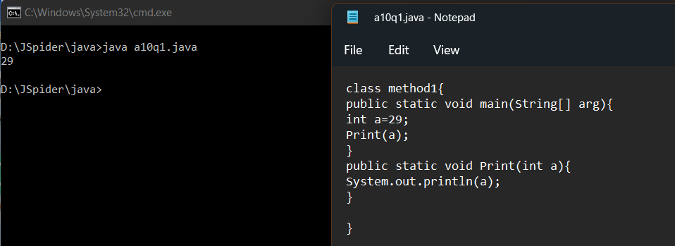

Q2. Create a method to accept float argument and return nothing.

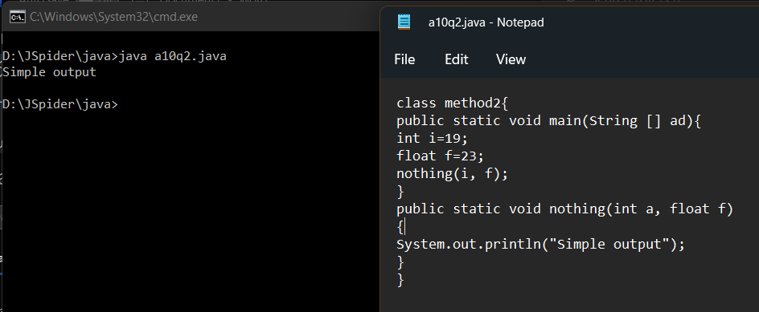

Q3. Create a method to accept boolean, float, double and return nothing.

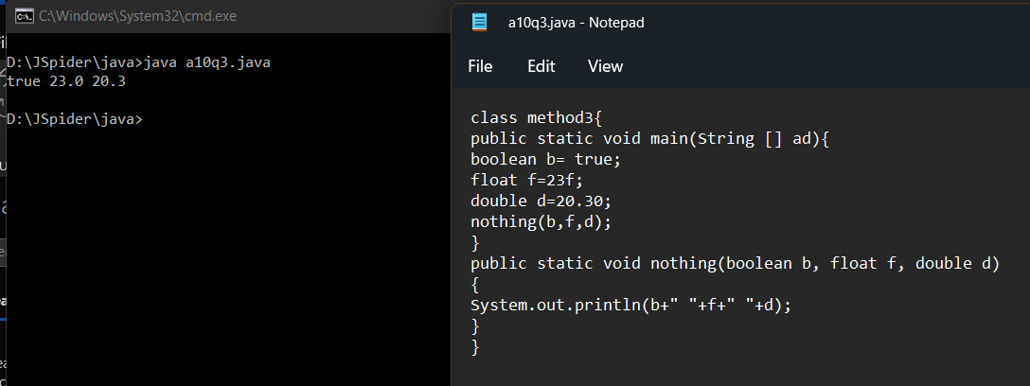

Q4. Create a method to accept int, int, float, double and return nothing.

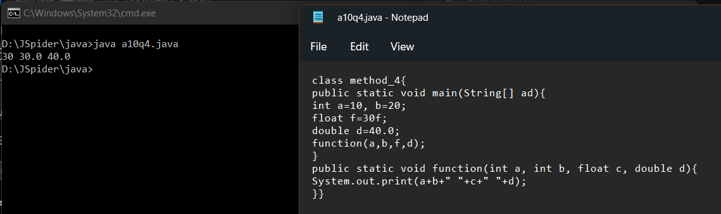

Q5. Create a method to accept byte, short, int, float, double, char, string and return nothing.

